$ Git clone (paste the link of your branch)
Click on that green box named CODE and copy the https link in gitbash
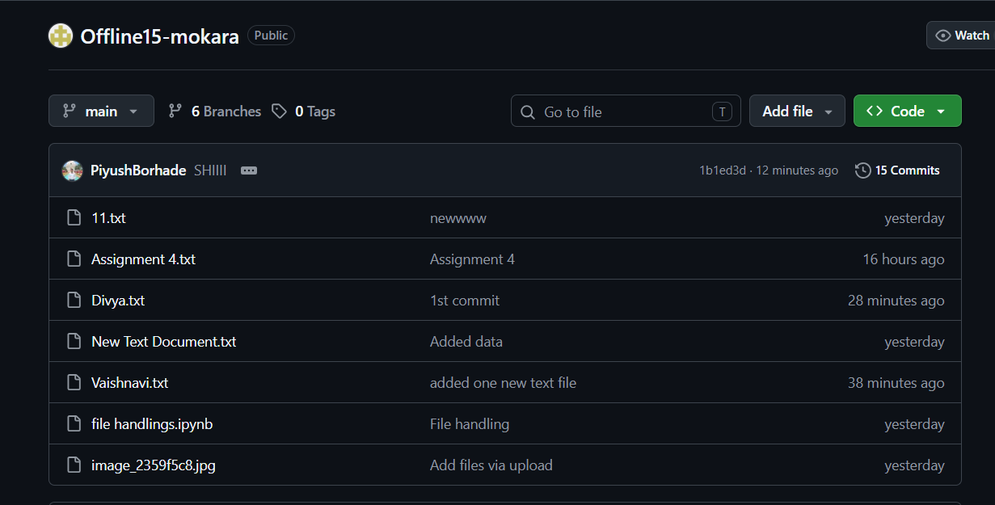

Open the mokara (the one you have created on github) folder and open gitbash in that folder
Folder is opened in desktop

$ Pwd

Go in that mokara folder
Copy offline-mokara (path for folder) and paste in gitbash
Cd (paste the path)

Create New text document in that folder
Write a text in it

$ Git status

$ Git add .

$ Git status
Goes into staging area

$ Git commit -m “name it”

$ Git push
Check github repo of offline mokara

To go for Main branch to feature branch
Git checkout branch_name

